RECIPE BLOG

NAME: VANGA SREEJA

REG NO: 9990

EMAIL : VSREEJA64@GMAIL.COM

1. **INTRODUCTION:**

The Recipe Blog website, titled *Flavorsome Recipes*, is a digital platform created to share and celebrate the rich diversity of Indian cuisine. It offers users a collection of traditional and popular recipes, presented in an easy-to-follow format with appealing visuals. This website aims to inspire cooking enthusiasts, from beginners to experienced chefs, by providing detailed instructions and tips for preparing a variety of dishes such as Masala Dosa, Biryani, Upma, and more.

By combining aesthetics with functionality, the Recipe Blog serves not only as a source of culinary knowledge but also as a community space to explore and appreciate Indian flavors. The project emphasizes simplicity, usability, and an engaging user experience, making cooking accessible and enjoyable for everyone.

1. **OBJECTIVE:**

The primary objective of the Recipe Blog website is to create an engaging and user-friendly platform that:

* Showcases a variety of traditional and modern Indian recipes.
* Provides clear and easy-to-follow cooking instructions with appealing visuals.
* Encourages users to explore regional cuisines and try new dishes at home.
* Offers a responsive design for seamless access across different devices.
* Enhances user experience with intuitive navigation and organized recipe categories.
* Promotes culinary knowledge sharing and fosters a love for cooking among users of all skill levels.

By fulfilling these objectives, the website aims to become a reliable source of inspiration for anyone interested in cooking flavorful Indian dishes.

1. **TECHNOLOGY USED:**

To develop the Recipe Blog website, the following tools and technologies were utilized:

1. Frontend Technologies

* HTML5: For structuring the web pages and content.
* CSS3: For styling the website with custom layouts, fonts, colors, and responsive design.
* Embedded CSS: For incorporating creative, page-specific styling directly within each recipe file.

2. External Resources

* Google Fonts: To enhance typography with stylish fonts like *Josefin Sans*.
* Font Awesome: For adding social media icons and enhancing visual aesthetics.
* Image Sources: High-quality food images were used from the internet (via royalty-free or appropriately credited sources).

3. Design Tools

* VS Code (Visual Studio Code): As the primary code editor for writing and managing HTML and CSS files.
* Google Chrome: For testing and debugging the site layout and responsiveness.
* Responsive Design Mode: To ensure the website performs well on both desktop and mobile devices.

4. Hosting & Sharing (for submission)

* GitHub / Google Drive: For storing and sharing project files and the report as per internship guidelines.

**4. FEATURES:**

The **Recipe Blog** website includes several engaging and user-friendly features designed to enhance the cooking experience and make recipe discovery enjoyable:

**🔹 1. Homepage with Hero Section**

* An attractive banner that welcomes users with a tagline and a clear call-to-action (“Start Cooking” button).

**🔹 2. Navigation Bar**

* A responsive and accessible navigation bar with links to **Home**, **About**, **Recipes**, **Categories**, and **Contact**.

**🔹 3. About Us Section**

* A brief introduction about the website, its purpose, and how it supports users in exploring Indian cuisine.

**🔹 4. Featured Recipes**

* A gallery of 8 popular South Indian recipes like Masala Dosa, Idli, Upma, Pongal, Rasam Rice, Biryani, and Chicken Curry.
* Each recipe is presented in a card layout with an image, short description, and a **View Recipe** button.

**🔹 5. Individual Recipe Pages**

* Separate HTML pages for each recipe featuring:
  + Ingredients
  + Step-by-step cooking instructions
  + Embedded CSS for visual appeal and consistency

**🔹 6. Contact Section**

* A contact form with fields for name, email, and message.
* Contact information is provided including address, phone, and email.

**🔹 7. Footer with Social Media Icons**

* Social media icons (Facebook, Twitter, Instagram) allow users to connect or follow.
* A copyright statement.

**🔹 8. Responsive Design**

* Ensures that the website displays correctly on various devices, including desktops, tablets, and smartphones.
  1. **CHALLENGES**

1. Ensuring responsive design across devices
2. Linking individual recipe pages properly to avoid file path errors
3. Maintaining visual consistency throughout the site
4. Structuring readable and informative recipe pages
5. Time management during a self-paced internship
6. Adding basic form validation for contact inputs
   1. **CONCLUSION:**

The Recipe Blog project successfully demonstrates the fundamentals of front-end web development using HTML and CSS. It serves as an excellent platform for food enthusiasts to share and discover new dishes. Through this internship task, key web development skills were practiced including layout design, content structuring, and responsive styling.

* 1. **FUTURE ENHANCEMENTS:**
* Add search functionality for quick recipe lookup
* Include categories for filtering recipes (e.g., breakfast, lunch, dinner)
* Integrate a backend using PHP or Python for dynamic recipe management
* Allow user login/signup and recipe submissions
* Add video tutorials and nutrition facts to each recipe page
  1. **SCREENSHOTS:**

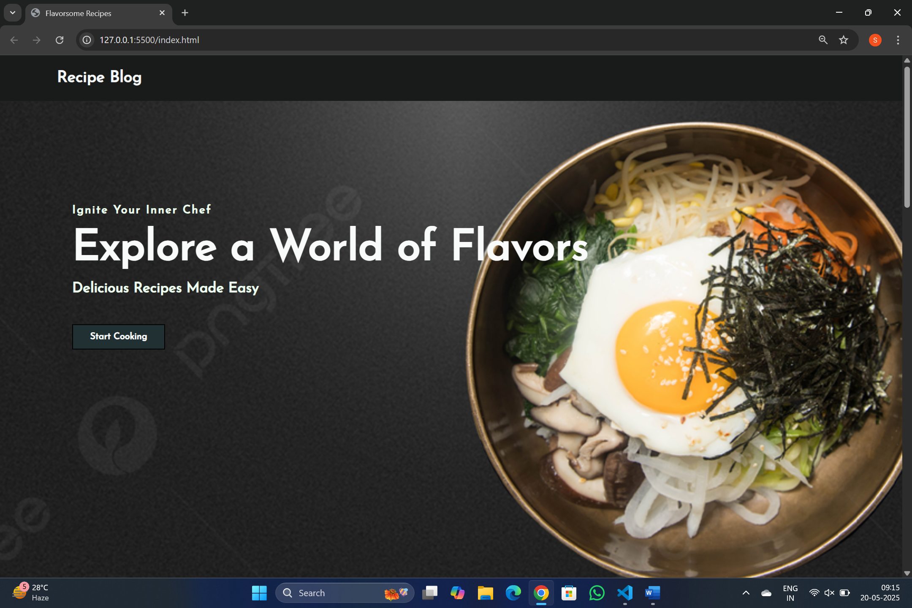

HOME PAGE

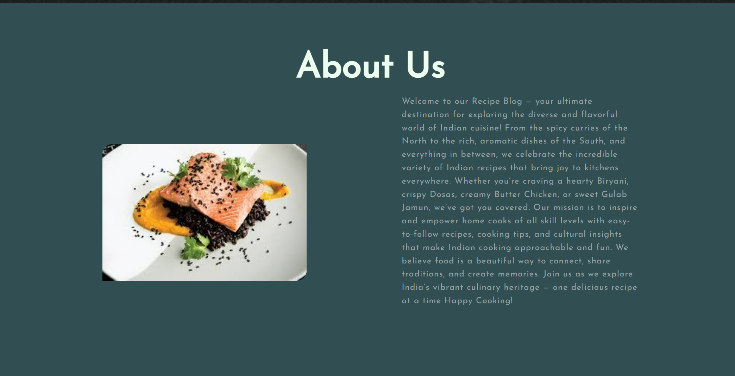

ABOUT US PAGE

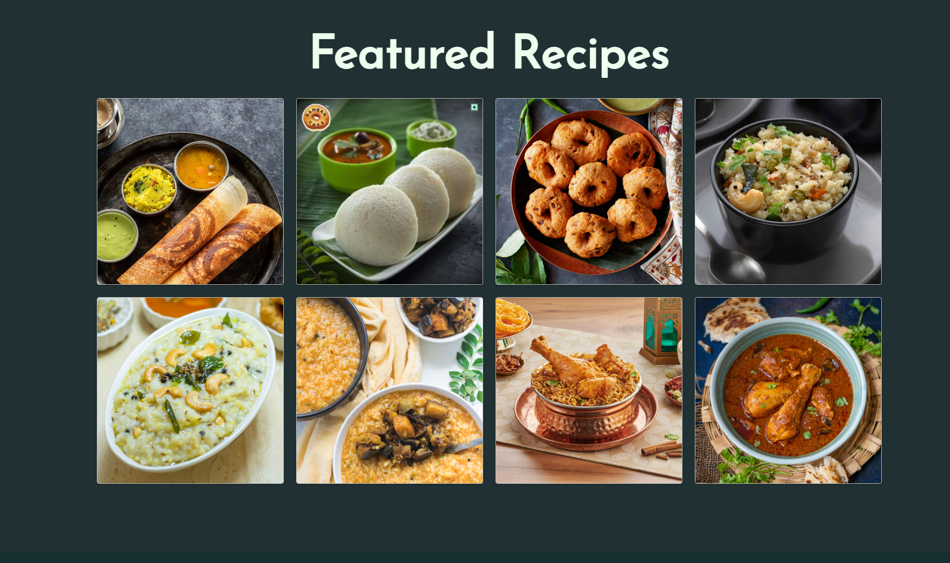

FEATURED RECIPES

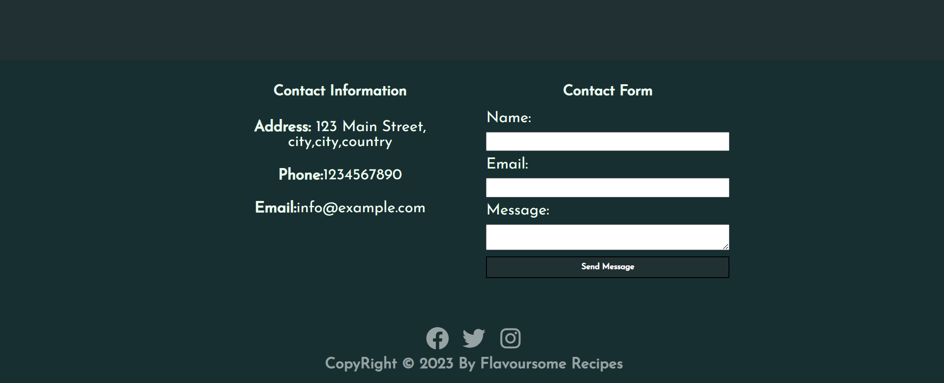

CONTACT PAGE

**Submitted By:**

VANGASREEJA   
Self-Paced Web Development Internship Project